|  |
| --- |
| ITECH7602 PROJECT |
| SOFTWARE PROJECT MANAGEMENT PLAN |
|  |

Raja Sekhar Masina - 30124524

Anil Rai - 30129276

Bobby Sri Harsha Sajja - 30129790

Ashok Kumar Najani - 30129695

Table of Contents

PROJECT SUMMARY 2

PROJECT SCOPE 2

STAKEEHOLDERS 3

Client Contract Form 4

ASSUMPTIONS AND CONSTRAINTS 5

ASSUMPTIONS 5

CONSTRAINTS 5

TEAM CONTRACT AND PROCESSES 5

INDUVIDUAL ROLES AND RESPONSIBILITIES 5

TEAM PROCESSES 6

TEAM RULES 6

TEAM COMMUNICATION PLAN 7

BACKUP AND VERSION CONTROL PLAN 7

PROJECT PLAN 7

WORK BREAKDOWN STRUCTURE 7

SCHEDULE RESOURCE ALLOCATION 9

BUDGET 10

QUALITY ASSURENCE STATEMENT AND PALN 10

WORK VERIFICATION 10

QUALITY FEEDBACK 11

CORRECTIVE ACTION 11

RISK MANAGEMENT PLAN 11

MISCOMMUNICATION: 11

TOOLS AND TECHNOLOGY TO BE USED: 12

LACK OF EXPERIENCE: 12

TIME SHORTAGE: 12

RISK INVOLVED WITH RESOURCES: 13

REFERENCES 13

# PROJECT SUMMARY

This Software project management plan has been implemented to define and document the project management goals and deliverables of the Vital Education project. It includes the scope, stakeholder information, work breakdown structure, budget as well as risk management strategies. Vital Education Pty Ltd is an institute that offers various certified training courses. This project involves implementing a web based application that includes all the basic pages as well as the details about the courses they offer. It also involves implementing a payment system through which customers can book the courses and pay the fees online. Introducing online booking could be a big advantage for the institute as a lot of customers might prefer to book courses online rather than going to an office. A learning management system is be integrated as a part of the system where all the enrolled students can access their courses and interact with the lecturers. This improves the learning quality of the students.

# PROJECT SCOPE

The scope of the project is to develop a web based application for a training institution. This application should provide a way for the customers to browse through the different courses available and book desired courses online. An enrolled customer should be able to access all the course information and materials that are available in the integrated learning management system. As the courses or other information in the website could change from time to time, the whole system is supposed to be developed in a way that administrator should have the higher privileges and could modify any information in the application.

# STAKEEHOLDERS

The stakeholders for this project includes

Vital Education Pty Ltd head

Vital Education employees

XP consultancy

Vital Education students

Project supervisor, professor and tutor

Our Team members

# Client Contract Form

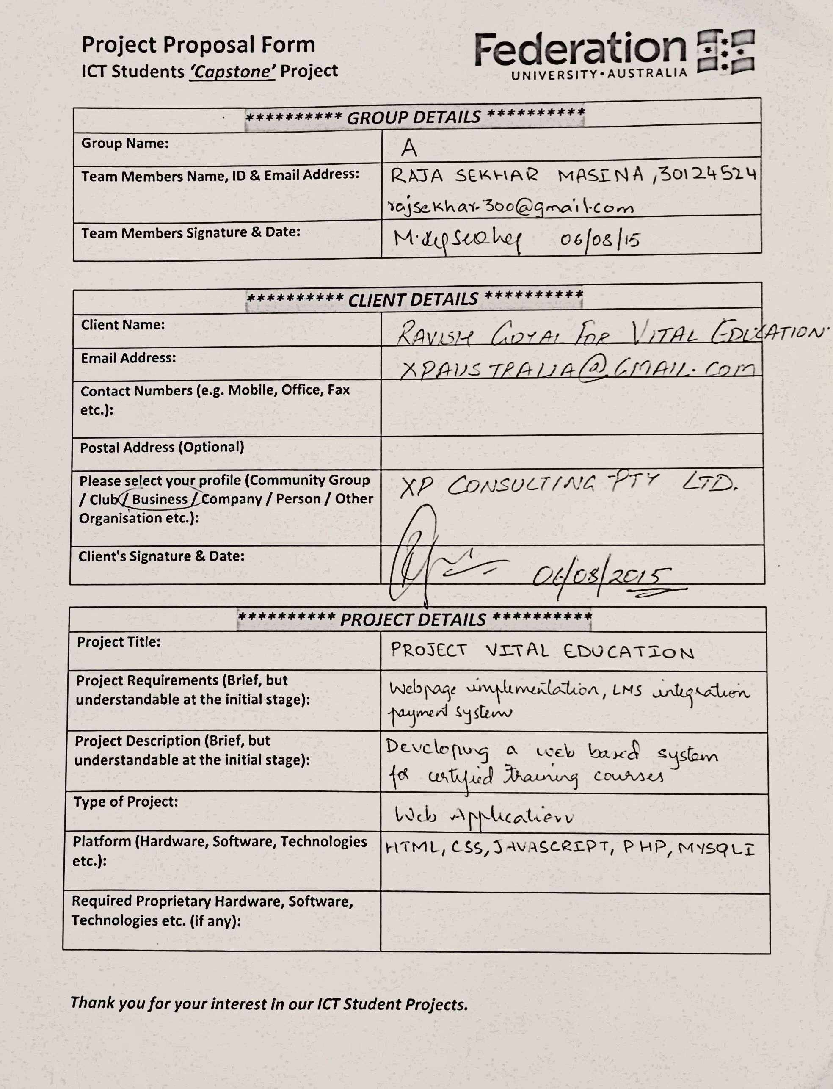

# ASSUMPTIONS AND CONSTRAINTS

## ASSUMPTIONS

The client provides all the necessary information when required.

Project scope will remain unchanged.

All the team members will be able to accomplish their assigned tasks in time

It is assumed that the project outcome will be bug free

It is assumed that all the team members have necessary skills to develop the application

## CONSTRAINTS

Project should be completed before the deadline.

Using some specific technologies which we had not used before

Completing the project within specified budget without compromising with quality

Implementing a system that will sustain for a long duration

Delays in any of the milestones will mount some pressure on the team for upcoming milestones

# TEAM CONTRACT AND PROCESSES

All the team members are committed to dedicate about 13 hours a week that sums up to be around 150 hours of total time spent for completing the project.

## INDUVIDUAL ROLES AND RESPONSIBILITIES

**Raja Sekhar Masina: Programmer and Team Lead**

Responsibilities:

-Plan and Design UI/UX components

-Implement server side scripting

-Design and develop mysql database

-Coordinate and allocate necessary resources to the team members

**Anil Rai: Frontend Developer**

Responsibilities:

-Plan and Design UI/UX components

-Develop front end user interface

-Implement client side scripting

-Conduct application usability tests

**Bobby Sri Harsha Sajja: System Analyst**

Responsibilities:

-Analyse the project requirements

-Identify the feasible solutions

-Document all the changes to the system

**Ashok Kumar Najani: Quality Assurance and Software Tester**

Responsibilities:

-Monitor the quality of the outcomes

-Test the application to identify the bugs

-System maintenance

# TEAM PROCESSES

## TEAM RULES

All the team members are supposed to spend around 150 hours each in a span of 12 weeks on the project development.

All the team members are required to attend the scheduled meetings every week and are supposed to be present till the meeting completes.

Each team member is solely responsible for the task assigned to them.

Confront all the issues directly and promptly.

Any decision is to be made in the presence of all the members.

All the members take equal responsibility in completion of the project.

A healthy environment is to be maintained and everyone treats other members with respect.

## TEAM COMMUNICATION PLAN

All the team members had accepted to dedicate a particular day for the project discussions. The meeting span is of four hours on every Friday where all the team members will discuss about the project progress and set upcoming weekly tasks. Every member made self-committed to work at any point of time, been in tact with no fail. During other days, team members will communicate through mails and others means which made us feel connected.

## BACKUP AND VERSION CONTROL PLAN

We created a google drive account to share the information between us with ease. Made a life easy for the team in terms of communicating and updating with the needs. A log is being maintained to note down the history of tasks completed, tasks in progress and tasks that are to be accomplished.

In parallel, a diary is being maintained as a backup just in case of data loss in the log or network inconsistencies. It can be considered an alternative for our communicating means which helped a lot and going to help in further as well.

# PROJECT PLAN

## WORK BREAKDOWN STRUCTURE

1. **Planning**
   1. Define project scope and deliverables
   2. Construct schedule and budget reports
   3. Develop base structure
   4. Schedule individual tasks
2. **Analysis**
   1. Gather all the necessary requirements
   2. Analyse the project requirements
   3. Identify various modules in the project
   4. Document the requirements
3. **Design**
   1. Frontend
      1. User Interface design
      2. Implement a template
      3. Review UI usability
      4. Finalize a template
      5. Define JavaScript functionalities
   2. Backend
      1. Define database elements
      2. Construct relational tables
   3. Technical Specifications
      1. Implement technical specifications
      2. Document design specifications
4. **Implementation**
   1. Frontend development
      1. Implement Functional requirements
         1. Develop basic webpages
         2. Implement cascading style sheet
         3. Code logical functionalities
         4. Refine code base
         5. Implement and integrate payment system
         6. Integrate learning management system
      2. Implement Non-functional requirements
         1. Implement cascading style sheets
         2. Implement documented UI design
         3. Review webpage functionality
   2. Backend development
      1. Construct database tables
      2. Implement server side script
      3. Finalize table structure
      4. Integrate database with frontend implementation
   3. Review implementation
   4. Webpage content inclusion
5. **Testing**
   1. Test end user environment
      1. Test database capabilities
      2. Check transaction outcomes
   2. User acceptance test
   3. Report results
   4. Bug fixes
6. **Installation**
   1. Domain registration
   2. Webpage content inclusion
   3. Website hosting
   4. Release application online
   5. Final Documentation
7. **Training**
   1. Provide client training
      1. Identify trainees
      2. Implement schedule
      3. Train users
      4. Formal acceptance

# SCHEDULE RESOURCE ALLOCATION

|  |  |  |  |  |  |
| --- | --- | --- | --- | --- | --- |
|  |  | **Resources** | **Duration** | **Start Date** | **End Date** |
| **1** | **Design** |  | **2 weeks** | **30-07-15** | **12-08-15** |
|  | Design UI | Raj, Anil | 3 days | 30-07-15 | 01-08-15 |
|  | Plan frontend | Anil, Harsha | 4 days | 02-08-15 | 05-08-15 |
|  | Plan backend | Raj, Ashok | 5 days | 06-08-15 | 10-08-15 |
|  | Check design quality | Ashok | 1 day | 11-08-15 | 12-08-15 |
|  | Documentation | Harsha | 1 day | 12-08-15 | 12-08-15 |
| **2** | **Implementation** |  | **7 weeks** | **13-08-15** | **01-10-15** |
|  | Webpage development | Anil, Harsha | 12 days | 13-08-15 | 24-08-15 |
|  | Database Implementation | Raj, Ashok | 10 days | 25-08-15 | 03-08-15 |
|  | Client side scripting | Anil | 9 days | 04-08-15 | 12-08-15 |
|  | Server side scripting | Raj | 14 days | 13-08-15 | 26-08-15 |
|  | Reports | Ashok, Harsha | 4 days | 27-08-15 | 01-09-15 |
| **3** | **Testing** |  | **1 week** | **02-10-15** | **09-10-15** |
|  | Interface testing | Ashok | 2 days | 02-10-15 | 03-10-15 |
|  | Server side testing | Ashok | 2 days | 04-10-15 | 05-10-15 |
|  | Bug fixes | Raj, Anil | 3 days | 06-10-15 | 09-10-15 |
| **4** | **Installation and Training** |  | **1 week** | **10-10-15** | **16-10-15** |
|  | System installation | Harsha | 1 day | 10-10-15 | 10-10-15 |
|  | Final Documentation | Raj, Anil, Ashok, Harsha | 2 days | 11-10-15 | 12-10-15 |
|  | Client training | Raj, Anil | 4 days | 13-10-15 | 16-10-15 |

# BUDGET

**Team Expenses**

|  |  |  |  |  |
| --- | --- | --- | --- | --- |
| **Team Member** | **Role** | **Working hours** | **Hourly rate** | **Total** |
| Raja Sekhar Masina | Programmer and Team Lead | 170 | $40 | $6800 |
| Anil Rai | Front end Developer | 170 | $38 | $6460 |
| Bobby Sri Harsha Sajja | Systems Analyst | 150 | $38 | $5700 |
| Ashok Kumar Najani | Quality Assurance and Software Tester | 150 | $38 | $5700 |
|  |  |  |  | **$24660 AUD** |

**Software and Hardware Expenses**

|  |  |  |  |  |
| --- | --- | --- | --- | --- |
| **Product** | **Purpose** | **Quantity** | **Cost /Product** | **Total** |
| Laptops | To develop the application | 5 | $2000 | $10000 |
| Licensed Operating systems | Used to run the software required for the project | 5 | $500 | $2500 |
| Server | To host the website | 1 | $1500 | $1500 |
| Dreamweaver | IDE to implement the code | 5 | $300 | $1500 |
| Aptana | IDE to implement servers ide scripting | 5 | $200 | $1000 |
| Other hardware expenses | Various other software utilities | - |  | $3000 |
| Other software expenses | Various other hardware utilities | - |  | $3000 |
|  |  |  |  | **$22500 AUD** |

# QUALITY ASSURENCE STATEMENT AND PALN

## WORK VERIFICATION

Assuring the quality in the present days with emerging technologies by bringing a qualitative output providing competitive environment with the other organisations. Quality assurance is a part of quality management to provide the best output.

Software quality assurance is providing the standards, procedures and process are correct with in the project and appropriately done for the project and have been implemented correctly. To maintain the quality of the software we use the present day technologies that are assigned and make sure them competent with the upcoming technologies that would be emerged in future.

## QUALITY FEEDBACK

For the quality of the outcome frequent verification of the outcomes of the tasks and giving some feedback. It will make us to clear the bugs at the initial stages which inturn helps us in further. The quality assurance plan will helps in this perspective.

## CORRECTIVE ACTION

Whatever the work teams has done this quality assurance plan will give an option for us to correct/change if any needed. We can try to find the solution for the errors which specifically known as corrective action.

# RISK MANAGEMENT PLAN

Project life cycle is critical, so as a good project manager, one should plan carefully for the project analysing all the possible risks involved in it. This project also involves many susceptible or unsusceptible risks which should be avoided to conduct the project successfully. While brainstorming about the risks involved we have come up with four distinct categories of risks that may arise while working in the project. These categories are described as follows.

* **Risk involved to the work.**
* **Risk involved to managing the project.**
* **Resource management risks.**
* **Risk with budgets and time frame.**

Those risks involved in the work are the most difficult and challenging task which should be addressed in appropriate manner. These risks are related to the technical details like development of the framework, testing of the software, refactoring the software, quality assurance and security. While working on the project, our programmer might be sick or not able to continue the project. In this case, we have plan to implement pair programming technique. The development team will be working in pair and they will concurrently be involved with the management team to communicate with them about the project progress.

Following topics may be the problematic approaches to our project which are discussed and listed with the appropriate solution.

## MISCOMMUNICATION:

**Risk involved in it:** Very high

**Preventive measure to the risk:** Team meeting will be conducted every week at 10 am on Friday. At this meeting, all the team members will discuss the progresses in the project, unsolved issues, and challenges to the task and brainstorm problem solving skills to the challenges. At this meeting we also plan for next step of the project. It is mandatory to attain the meetings by all the members, if not then we will record the absent member in our **project progress report.**

## TOOLS AND TECHNOLOGY TO BE USED:

In real project, we may be using wrong tool or technology which might be known at the middle of the project. This will create a huge pressure in the time management plan. So we have spare some time to research about the tools and technology we will be using in our project. This will hugely assist us in running our project in time.

**Risk Involved:** high

**Preventive measure:** Understand the appropriate tools and technology first. Our team will be dealing with the tools and technology that we have selected and we will discuss the efficiency of the tools and technologies we have been using in our project in the meetings.

## LACK OF EXPERIENCE:

It is easy to misguide the project because of the lack of experience in the project. As we are in the novice to project paradigm, we may have high chances of getting involved in dark side of the project. So we will be contacting the project supervisor more frequently.

**Risk Involved:** Very high

**Preventive measure:** Continuous consultation with project supervisor and experienced project manager is the only key to lead the project successful. This will be done accordingly.

## TIME SHORTAGE:

For any project time management is the most important factor in project management plan. It is more natural that project team will be dealing lazily during first stage of the project while at the end, it will be pressurized to all the members and will be conflicts among the team members. For this purpose, we have to deal with the project with vigorous energy from the beginning of the project. The WBS should be strictly followed by the team members. And the project progress report will be adherently compared with the work progress. This is very important for successfully submitting the project.

**Risk Involved:** Very high

**Preventive measure:** time line should be strictly followed by the development team. This is assured by project progress report. Technically, we will have discussion about these time vs project progress report.

## RISK INVOLVED WITH RESOURCES:

There are many tools and resources we will be using and these tools and resources involves many risks as follows.

* Software Development Toolkit corrupted with viruses.
* Loss of data or part of project programs
* Server crash
* Database crash

**Risk Involved:** Very high

**Preventive measure:**  All these risks are recorrected in the progress of our project dealing with the project progressively. It is our challenges to get the success.

# REFERENCES

Gido, J., & Clements, J. (2014). *Successful project management*. Cengage Learning.

Burke, R. (2013). *Project management: planning and control techniques*. New Jersey, USA.

Kerzner, H. R. (2013). *Project management: a systems approach to planning, scheduling, and controlling*. John Wiley & Sons.

Boehm, B. W., & Ross, R. (1989). Theory-W software project management principles and examples. Software Engineering, IEEE Transactions on, 15(7), 902-916.

Boehm, B. W. (1991). Software risk management: principles and practices.*Software, IEEE*, *8*(1), 32-41.